Due date for this assignment: 2025-07-23, 23:59 IST.
You may submit any number of times before the due date. The final submission will be considered for grading.

Note: This assignment will be evaluated after the deadline passes. You will get your score 48 hrs after the deadline. Until then the score will be shown as Zero.

1 point
Table: M2W1G1 gives functions in Column A with their types in column B and their graphs in Column C.
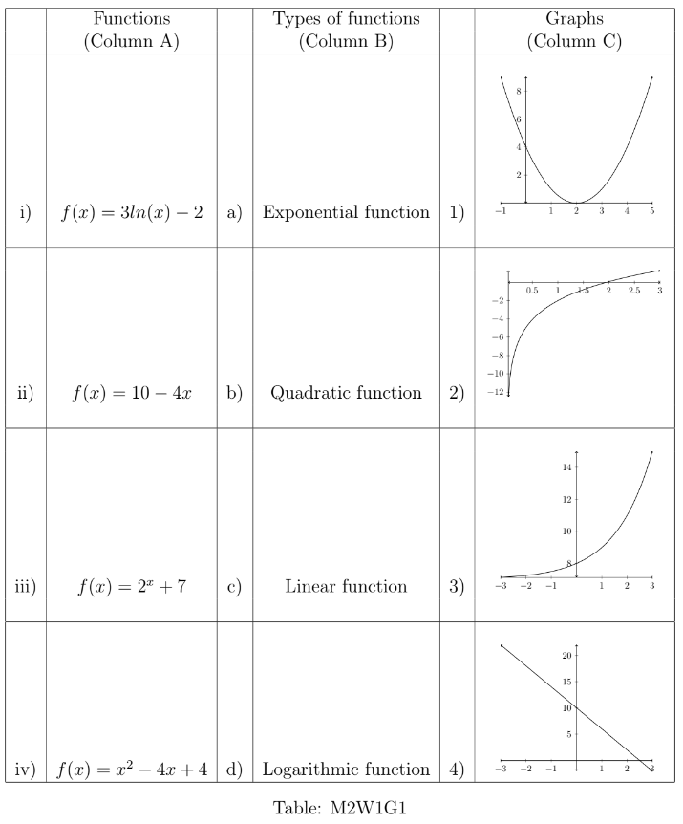
Choose the options which represent the correct matching of a given function with its type and its graph.
i) → d) → 2)
→
→
i) → a) → 2)
→
→
ii) → c) → 1)
→
→
ii) → c) → 4)
→
→
iii) → d) → 2)
→
→
iii) → a) → 3)
→
→
iv) → b) → 1)
→
→
iv) → b) → 3)
→
→

1 point
Suppose f(x) is a strictly increasing function and g(x) is a strictly decreasing function. If the curves represented by f(x) and g(x) intersect at x=x0​, then choose the set of correct options.
f(x)
g(x)
f(x)
g(x)
x=x0
f(x)≥g(x) for all x≥x0​.
f(x)≥g(x)
x≥x0
There exists a point x1​>x0​ such that f(x1​)=g(x1​).
x1>x0
f(x1)=g(x1)
g(x)≥f(x) for all x≥x0​.
g(x)≥f(x)
x≥x0
g(x)≥f(x) for all x0​≥x.
g(x)≥f(x)
x0≥x
f(x)≥g(x) for all x0​≥x.
f(x)≥g(x)
x0≥x

Suppose an​=3n+2712n2​−n+54n2+23​. Find the value of n→∞lim​an​.
an=12n23n+27−4n2+23n+5
lim⁡n→∞an
1 point

In the graphs given below, how many of the curves have a (unique) tangent at the origin (i.e., (0, 0))?
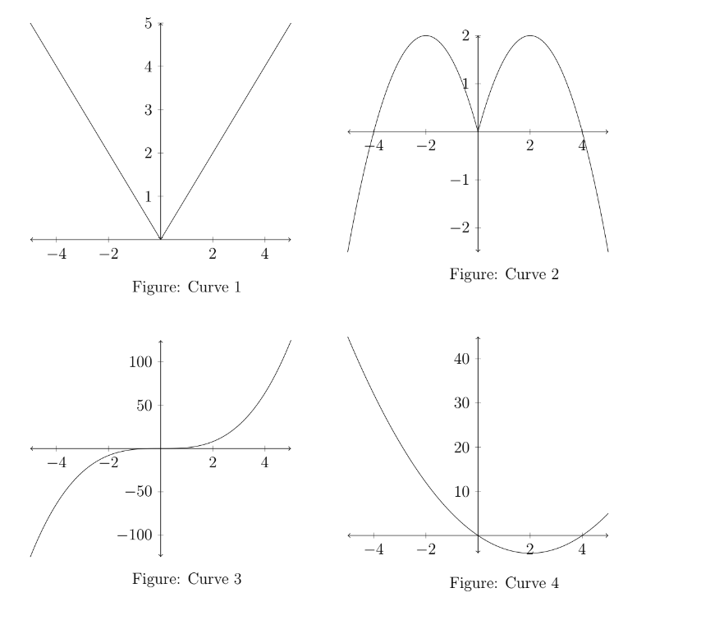
0 points

Limits of some standard functions are given below:
- x→0lim​xlog(1+x)​=1
lim⁡x→0log(1+x)x=1
- x→0lim​xex−1​=1
lim⁡x→0ex−1x=1
- n→∞lim​n(n!2πn​​)n1​=e
lim⁡n→∞n(2πnn!)1n=e
- n→∞lim​nn!​n​=e
lim⁡n→∞nn!n=e
Using the given information, find the value of n→∞lim​enn!​[log(1+n28​)−(2πn​)n1​(e(n21​)−1)​].
lim⁡n→∞en!n[log(1+28n)−(e(21n)−1)(2πn)1n]
1 point

Find the limit of the sequence given by an​=n23+5+7+...+(2n−1)​, (where n∈N∖{0}).
an=3+5+7+...+(2n−1)n2
n∈N∖{0}
1 point

Find the value of 5x→16+lim​⌊x⌋−3x→2−lim​⌊x⌋, where ⌊x⌋ denotes the greatest integer less than or equal to x.
5lim⁡x→16+⌊x⌋−3lim⁡x→2−⌊x⌋
⌊x⌋
x
1 point
Suppose a company runs three algorithms to estimate its future growth. Suppose the error in the estimation depends on the available number (n) of data as follows:
(n)
- Error in estimation by Algorithm 1: an​=6n2+1n2+5n​.
an=n2+5n6n2+1
- Error in estimation by Algorithm 2: bn​=81​+(−1)nn1​
bn=18+(−1)n1n
- Error in estimation by Algorithm 3: cn​=7enen+4​
cn=en+47en
where n∈N∖{0}.Suppose the company has a large amount of data in hand (we can assume n tends to ∞). Using the information given above, answer the questions below.
n∈N∖{0}
n
∞

1 point
Which of the following statements is (are) correct?
Error in estimation by Algorithm 2 will be 0.500.
Error in estimation by Algorithm 2 will give the minimum error.
Error in estimation by Algorithm 2 will give the maximum error.
Both Algorithm 1 and Algorithm 2 will give the same error and that will be the maximum.
Error in estimation by Algorithm 1 will be 0.166 approximately.

1 point
Suppose a new algorithm is designed to predict the growth of the company in future and the error in estimation by the new algorithm is given by an​−bn​, where an​ and bn​ are the same as defined earlier. Choose the set of correct options.
an−bn
an
bn
The error in estimation using the new algorithm is less than the error in estimation using Algorithm 1.
The error in estimation using Algorithm 2 is less than the error in estimation using the new algorithm.
The error in estimation using the new algorithm is less than the error in estimation using Algorithm 3.
The error in estimation using the new algorithm cannot be compared with the error in estimation using Algorithm 3.

Suppose the company modified the error in estimation by Algorithm 3 as cn′​=ne(20n1​)−n.
What will be the new error in estimation by Algorithm 3? (Correct upto 3 decimal places)
cn′=ne(120n)−n
1 point

Submit Answers

